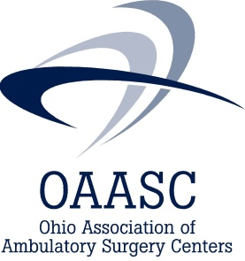
May 7, 2019
Members of the Ohio House of Representatives,
On behalf of the over 200 licensed Ohio ambulatory surgery centers and members of the Ohio Association of Ambulatory Surgery Centers (ASCs), we urge you to oppose language in Substitute House Bill 166 that would prohibit an ambulatory surgery center and other health care facilities from charging a facility fee.
Facility fees represent all of the costs of operating an ASC for surgical care delivery to patients, with the exception of the physician’s professional fees. For ASCs, in addition to the physical building, this facility fee covers everything involved in a surgery including the cost of equipment and appliances, nursing care, technicians and related services, diagnostic, sterilization items and services, pharmaceuticals, biologicals, surgical dressings, supplies, splints, casts, anesthesia materials and often implants.
Additionally, ASCs provide much needed and required state/federal mandated continuous training and education for their staff, which is funded through these facility fees.
Ambulatory surgery centers provide a cost efficient, high quality surgical option for many Ohioans, especially those who live in rural communities and have limited access to healthcare. Ohioans receive many preventive healthcare services in an ambulatory surgical setting, including colonoscopies, eye, ear, nose, and throat surgeries.
If ASCs are not able to be reimbursed for providing services as the language in Substitute House Bill 166 states, many, if not all of our facilities will cease to exist which will cause Ohioans to have an even more limited access to needed affordable healthcare services.
We ask that you remove the language related to reimbursement of facility fees in Substitute House Bill 166.
Sincerely,
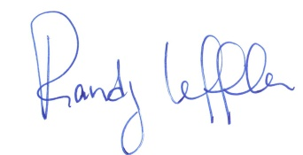
Randy Leffler
Executive Director
Ohio Association of Ambulatory Surgery Centers

